**YEAR 12 CHEMISTRY - ATCHE**

**END OF TOPIC TEST**

**EQUILIBRIUM**

**Recommended time: 50 minutes**

**Total marks**

**/ 56**

Name: _____________________________________________________

Teacher: _____________________________________________________

This test is in two parts.

**Section 1:** Multiple choice style test consisting of (15) questions. **(15 Marks)**

Each question is worth 1 mark.

Write your answers in the table provided.

Attempt **ALL** Questions

**Section 2:** Short and/or Extended Answer questions **(41 Marks)**

Write all answers in the spaces provided.

The marks allocated to each question are shown for each question

Note that ALL questions DO NOT carry an equal number of marks.

Read the questions carefully and keep an eye on the allocated time

Attempt **ALL** Questions

**Multiple Choice ( 15 Marks )**

1. The reaction of coal with steam in a vessel at constant volume produces a mixture of hydrogen and carbon monoxide gases.

C (graphite) + H2O (g)  **D** H2 (g) + CO (g) ΔH = 131 kJ mol – 1

Which one of the following would slow down the rate of reaction?

1. Decreasing the pressure of the steam.
2. Grinding up the coal.
3. Injecting CO gas into the reaction vessel.
4. Raising the temperature of the steam.
5. Gaseous hydrogen gas and oxygen gas are reacted to form steam as shown.

2H2 (g) + O2 (g)  2H2O (g)

The value of equilibrium constant, K, will depend on

1. the initial concentration of H2
2. the initial concentration of H2O
3. the temperature of the system
4. the volume of the reaction vessel
5. The equilibrium constant, K, for a gaseous phase reaction that occurs is shown below.

The chemical equation for this equilibrium is :

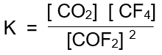

1. CO2 (g) + CF4 (g) **D** COF2(g)
2. CO2 (g) + CF4 (g) **D** 2COF2(g)
3. CO2F(g) **D** CO2 (g) + CF4 (g)
4. 2COF2(g) **D** CO2 (g) + CF4 (g)
5. Hydrogen gas, H2(g), is produced industrially from methane, CH4(g). The equation for the reaction is:

2H2O(g) + CH4(g) ⇌ CO2 (g) + 4H2(g)

If an inert gas argon is added to the equilibrium system at constant temperature and constant volume, the concentration of hydrogen will:

1. Increase
2. Decrease
3. not change
4. decrease and then increase
5. Which of the following does not change the **rate** of collisions between particles in a reaction?
6. Addition of a catalyst.
7. Increase in surface area.
8. Increase in temperature.
9. Decrease in the reaction volume
10. Which one of the following statements concerning the equilibrium reaction below is INCORRECT ?

CO2 (g) 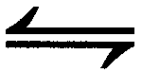 CO2 (aq) ∆H = -156 kJ

1. The equilibrium constant (K) for the dissolving of CO2(g) in water is increased by increasing the pressure of the system.
2. Carbon dioxide gas is less soluble in water as temperature increases.
3. Injecting more CO2(g) will cause an increase in the concentration of dissolved CO2 (aq).
4. The equilibrium constant (K) for the reverse reaction is unchanged unless a change in temperature occur.
5. Which of the listed changes will be certain to increase the partial pressure of NO(g) in the following system at equilibrium:

SO2(g) + NO2(g)  **⇌** SO3(g) + NO(g) + 42 kJ

|  |  |
| --- | --- |
| 1. Increasing the temperature | 1. Removing heat from the system |
| 1. Adding more SO3(g) | 1. Adding a catalyst |
| 1. Increasing the concentration of NO2(g) | 1. Increasing the pressure |
| 1. Decreasing the pressure |  |

1. (ii) and (v)
2. (ii), (iii) and (v)
3. (ii), (iv), (v) and (vi)
4. (i), (iv), (v) and (vii)
5. The Haber process involves the following equilibrium reaction: N2(g) + 3H2(g)  2NH3 (g)

A number of closed reaction vessels were set up containing the gases as shown in the table.

|  |  |
| --- | --- |
| **Reaction vessel** | **Gases initially present** |
| (i) | nitrogen, hydrogen |
| (ii) | nitrogen |
| (iii) | ammonia |
| (iv) | hydrogen, ammonia |

In which of the above closed reaction vessels would equilibrium be established after a period of time?

1. i only
2. ii and iii only
3. i, iii, and iv only
4. ii, iii, and iv only
5. A mixture of hydrogen gas and purple iodine vapour is sealed in a glass tube where it undergoes a reaction to form colourless hydrogen iodide gas. Which of the following could be used as a visible sign that equilibrium has been achieved?

H2 (g) + I2 (g) D 2HI (g)

1. Constant pressure.
2. Constant colour.
3. Constant mass.
4. Constant volume.

The next **two** question relate to the following equilibrium system:

2 NO2 (g)  N2O4 (g) ∆H = - 57.2 kJ/mole

brown colourless

A change is made at time (t1) to an equilibrium mixture of NO2 and N2O4 which achieved a new equilibrium at time (t2). A graph showing the rate offorward reaction is shown below.

1. Which one of the following describes the change that was made to the initial equilibrium system and the colour change that occurred between (t1) and (t2)?
2. The temperature was increased and the colour lightened.
3. The temperature was increased and the colour darkened.
4. The temperature was decreased and the colour lightened.
5. The temperature was decreased and the colour darkened
6. Which of the following changes would increase the **rate** at which the equilibrium is reached, without affecting the position of equilibrium?
7. increase pressure
8. increase temperature
9. decrease temperature
10. Adding a catalyst
11. An equilibrium mixture of four gases is represented by the following equation:

A(g) + 2B(g)  C(g) + D(g) ΔH> 0

The graph below shows the rate of the forward and reverse reactions versus time.

Which one of the following is consistent with the information given above?

1. Argon is added to the mixture at t1.
2. At t1, reactants are removed from the mixture.
3. The amount of products is higher at t2, compared to just before t1.
4. That change made at t1 results in an increase in the equilibrium constant at t2.

The four equations below represent different equilibrium systems.

1. After equilibrium was established in each system, the temperature was decreased, and the pressure was increased. In which system would these changes **both** result in an increased yield?
2. Equation 1
3. Equation 2
4. Equation 3
5. Equation 4

Questions 14 and 15 refer to the following information:

CO(g) + Cl2(g) ⇌ COCl2(g) ∆H = –108 kJ mol–1

1. Which of the following is the correct interpretation of the energy distribution diagram below, as the system changed from **T2 to T1**?

|  |  |  |
| --- | --- | --- |
|  | **Proportion of successful collisions between particles** | **Yield of COCl2** |
| a) | Increases | Increases |
| b) | Decreases | Decreases |
| c) | Increases | Decreases |
| d) | Decreases | Increases |

1. The system attained equilibrium with an initial volume of 5.00 L. The volume of the container was increased to a new volume (20.0 L) and equilibrium was re-established. Which of the following statements is true at this new volume?
2. The reverse reaction rate is faster and the partial pressure of CO(g) is higher at this new volume compared with the initial equilibrium.
3. The reverse reaction rate is faster and the partial pressure of CO(g) is lower at this new volume compared with the initial equilibrium.
4. The reverse reaction rate is slower and the partial pressure of CO(g) is lower at this new volume compared with the initial equilibrium.
5. The reverse reaction rate is slower and the partial pressure of CO(g) is higher at this new volume compared with the initial equilibrium.

**Short Answer ( 41 Marks )**

1. As a first step in the manufacture of nitric acid it has been suggested that nitrogen monoxide gas , NO, can be formed from nitrogen gas and oxygen gas in a reversible reaction.
2. Use the provided information to deduce an expression for the equilibrium constant (K).

|  |
| --- |
|  |

(1 mark)

1. Using the graph, predict the effect of an increase in temperature on the numerical value of K. Justify your prediction.

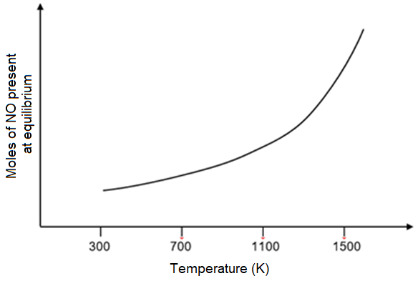

_______________________________________________________________________

_______________________________________________________________________

_______________________________________________________________________

_______________________________________________________________________

(4 marks)

1. When cooled, nitrogen monoxide reacts with oxygen gas to form gaseous nitrogen dioxide. Use the collision theory to explain how removing some nitrogen monoxide would change the position of this equilibrium.

_______________________________________________________________________

_______________________________________________________________________

_______________________________________________________________________

_______________________________________________________________________

(4 marks)

1. The reaction between carbon and hydrogen gas to form methane can be represented by the following equation:

C(s) + 2H2(g) ⇌ CH4(g) + 75kJ

1. State the overall effect on methane yield and forward reaction rate (increase, decrease, or no change) the following imposed changes would have.

|  |  |  |
| --- | --- | --- |
| **Imposed change** | **Effect on  methane yield** | **Effect on  forward reaction rate** |
| A suitable catalyst is added. |  |  |
| The volume of the reaction vessel is halved. |  |  |
| The temperature of the reaction vessel is decreased. |  |  |
| The partial pressure of H2 is increased. |  |  |
| Methane is removed and collected as soon as it is formed. |  |  |

(10 marks)

1. The activation energy for this process under current conditions is 200 kJ mol-1.

Use the following axes to sketch an energy profile diagram for this process.

**Label the: axes, reactants and products, activation energy, change in enthalpy.**

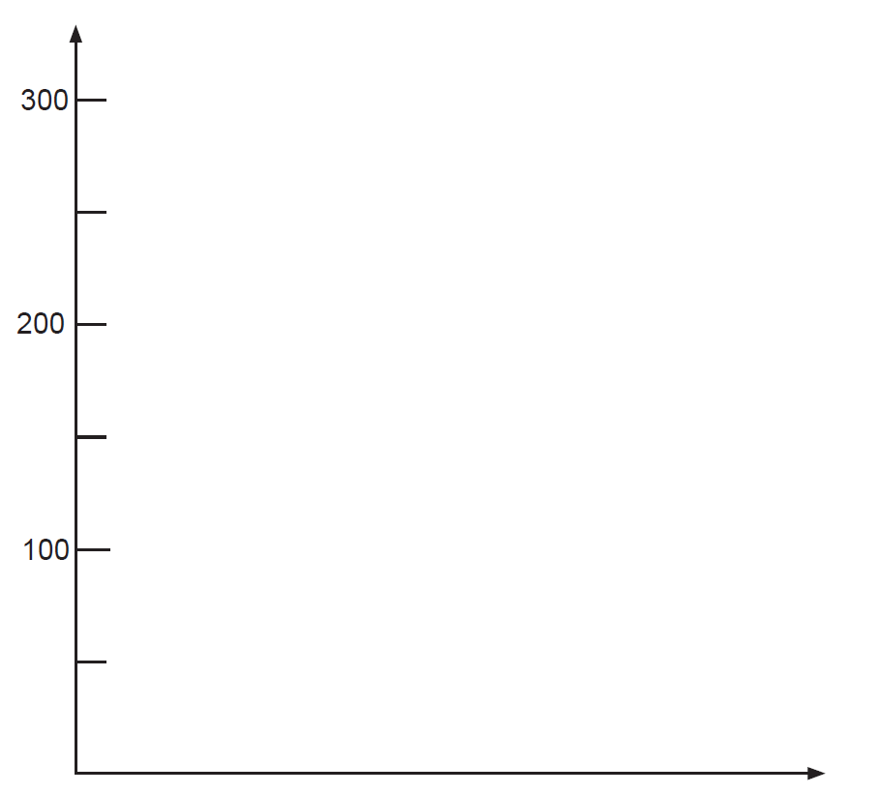(4 marks)

1. The concentrations of hydrogen and methane were plotted over time and the following graph was produced.

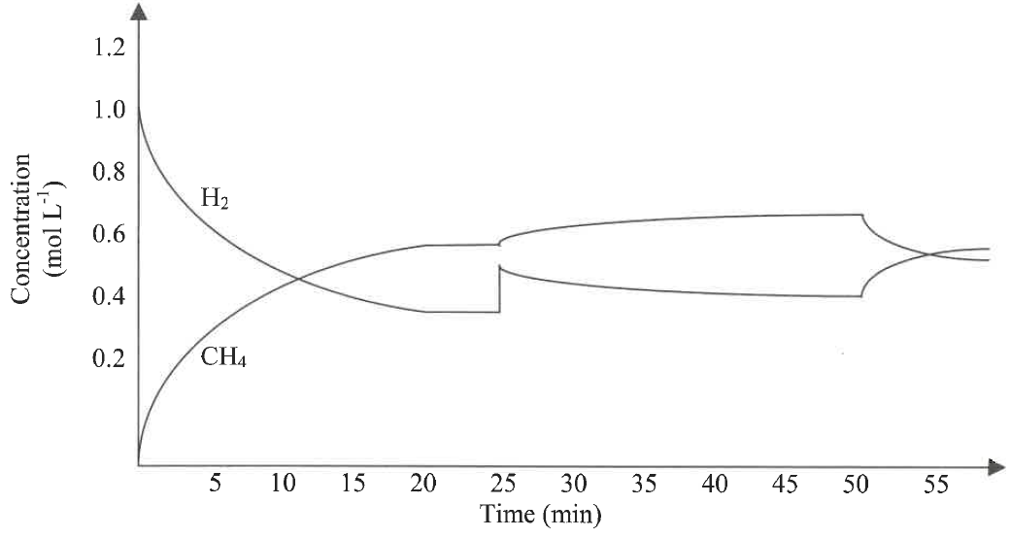

1. About what time was equilibrium first established? ________________________ (1 mark)
2. Suggest the changes imposed on the system at each time on the table below.

|  |  |
| --- | --- |
| **Time** | **Change imposed on system** |
| 25 mins |  |
| 50 mins |  |

(2 marks)

Another system containing the same species was at the equilibrium shown below.

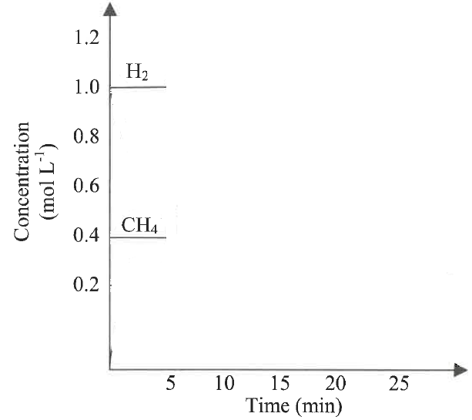

1. At 5 minutes the volume of the container was doubled. The system responded and re-established equilibrium at 20 minutes. Show the change in concentrations on the graph.
2. marks)
3. The two different coloured complex ions, [Co(H2O)6]2+(aq) and [CoCl4]2- exist together in equilibrium in solution in the presence of chloride ions. The equation is as shown below:

[Co(H2O)6]2+ (aq) + 4Cl- (aq)⇌ [CoCl4]2- (aq) + 6 H2O(l)

Pink blue

After a 3.00 mL sample of the initial equilibrium was placed in each of these test tubes, changes to each system were made by adding a different substance, as indicated in the table.

|  |  |
| --- | --- |
| Test tube | Substance added to the test tube |
| 1 | Some powdered [Co(H2O)6]SO4 |
| 2 | 1 - 2 drops of concentrated 10 mol/L hydrochloric acid |
| 3 | 1 - 2 drops of 0.250 mol/L AgNO3(aq) solution |

1. Complete the table below by predicting the change in concentration of species from initial concentration to and colour change in each test tube.

|  |  |  |  |  |
| --- | --- | --- | --- | --- |
| Test tube | Overall change in concentration  **increase (i), decrease (d), unchanged (u)** | | | Colour favoured  **(pink, blue or unchanged)** |
| [Co(H2O)6]2+ | [ Cl-] | [CoCl4 ]2- |
| 1 | . |  |  |  |
| 2 |  |  |  |  |
| 3 |  |  |  |  |

(6 marks)



1. Other than a colour change, what else should be observed in test tube 3?

_________________________________________________________________ (1 mark)

1. Using Collision Theory, explain your predicted observations when hydrochloric acid is added to test tube 2.

_______________________________________________________________________

_______________________________________________________________________

_______________________________________________________________________

_______________________________________________________________________

_______________________________________________________________________

_______________________________________________________________________

_______________________________________________________________________

_______________________________________________________________________

(4 marks)